**ACCOUNTING AND FINANCIAL ANALYTICS – ASSIGNMENT 3**

**TITLE: ANALYZING COMPETITIVE ADVANTAGE IN REAL COMPANIES**

**TOPIC: TECHNOLOGY SECTOR: AMAZON**

**CONSUMER GOOD SECTOR: NIKE**

**CONTENTS:**

1. **Introduction**
2. **Background**
3. **Competitive Advantages**
4. **Financial performance**
5. **Comparative Analysis**
6. **Assessment of sustainability**
7. **Conclusion**

**INTRODUCTION**

**TECHNOLOGY SECTOR : ( AMAZON)**

**Amazon is a multinational technology company founded by Jeff Bezos in 1994. Amazon is a completely online marketplace. It is one of the world’s largest e-commerce platform offerings a wide of range of products and services including electronics like Mobiles of different brands, Tabs, Laptops etc, groceries, Fashion like clothes for men, women, kids and also including footwear, accessories like wallets, silver jewellery , watches & smartwatches and sunglasses etc , stationery like notebooks , pens, pencils etc. It also includes furniture and home decor items.**

**Amazon has expanded globally operating in numerous countries and regions with a innovation and convenience. It has been expanded into new media, such as streaming media with Amazon Prime Video and hardware devices like Amazon Echo.**



**CONSUMER GOODS SECTOR: (NIKE)**

**Nike is a global leader in athletic footwear and accessories. It was founded in the year ‘1964’ as Blue Ribbon Sports by Bill Bowerman and Phil Knight. It officially became Nike Inc in the year 1971. The company is renowned for its innovative products, cutting-edge design, with a number of colours etc. It operates retail stores worldwide and sells its products through various channels including online platforms and promoting the product through cine actors and actress, content creators etc.**

**Nike offers a wide range of accessories to complement its athletic footwear and apparel. It includes bags for various activities like travel, sports and everyday use and backpacks like gym sacks and duffel bags etc, headwear like hats, caps, beanies and headbands for both performance and style and other items like socks for different sports (running, basketball, soccer), belts etc. In today’s generation, the youngsters are fond of Nike shoes. Overall, Nike’s popularity among youngsters remains high due to its reputation for quality, style and endorsement by top athletes and influencers.**

**According to survey, some of the youngsters wear Nike apparel and footwear daily for both casual and sports activities, while others use for only specific events and workouts. Nike also has a tagline as ‘JUST DO IT.’**

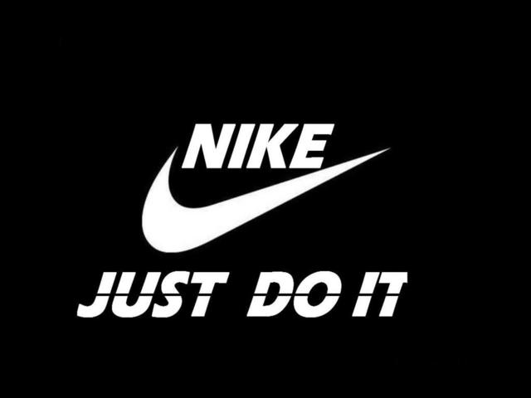

**COMPETITIVE ADVANTAGES:**

**Competitive advantage for Amazon:-**

1. **Brand Reputation: It has a strong and trusted brand reputation over these year by giving its commitment to customer satisfaction and convenience to customers and also by providing a seamless shopping experience, fast delivery and excellent customer service by responding immediately to customers queries. By this it has earned the trust and loyalty of millions of consumers or customers.**
2. **Technology Innovation: Technology innovations like Amazon Go (cashier-less stores) and Alexa (voice assistant) which has a separate app called ‘Amazon Alexa’ and can also be connected to phone with help of the Bluetooth. By connecting we can listen to songs etc. Continuous innovations leads to a step ahead of competitors in the market.**
3. **Market differentiation: It differentiates itself through various products, services and value-added services etc. Its product selection varies from daily need essentials to extreme high premium brand with consideration of customer preferences, tastes and needs.**

**For Nike:**

1. **Brand Reputation: It is know for its iconic logo i.e, ‘JUST DO IT’ and for innovative products like headbands, socks, belts etc. Nike has established strong brand reputation for its quality and performance and style. They also achieved through youngsters because of the advertisement campaigns done by the influencers etc.**
2. **Market leadership: It maintains its market leadership through the sports footwear and apparel i.e, clothing industry through continuous innovation of products so that it can be ahead of the competitors in the market. And it gave a commitment to social responsibility.**
3. **Economies of Scale: Nike has a benefit from EOS due to its large of production and distribution network throughout the global. By producing high volume of products it can spread its fixed cost for a large output with a average production per unit. Overall, EOS play a crucial role in Nike for its competitiveness in the market with the other small competitors and for the profitability in the sports footwear and other apparels.**

**FINANCIAL PERFORMANCE EVALUATION:**

**AMAZON:**

1. **MARKET SHARE: It holds a significant market share in e-commerce platform i.e, the online purchasing of products like accessories, stationery and footwear like shoes, heels, boots etc and many more and Amazon Web Services and digital streaming like Amazon Prime Video etc.**
2. **REVENUE GROWTH: By doing continuous innovation and expansions of new markets amazon has experienced a robust revenue growth and also gained the trust and loyalty from the customers.**
3. **ROI: The return on investment of amazon is ongoing investments in long-term growth. It aims to deliver value to its shareholder of the company through its growth.**
4. **PROFIT MARGINS: It reflects in managing costs and generating profits from the operations, while the company has operated with its thin PM due to its focus on growth and market dominance with the competitors.**

**Overall, strong revenue growth, healthy profits margins, positive ROI and market share indicates amazon’s competitiveness and financial stability. These are closely monitored by the analysts , investors and stakeholders to assess Amazon’s performance.**

**NIKE:**

1. **REVENUE GROWTH: By the influencer advertisement on the sports footwear, apparel and other accessories, the Nike has enjoyed the revenue growth over the years for its strong demand in the market. It has a worldwide recognition in the market and innovative products contribute to its RG.**
2. **ROI: A positive Roi indicates that the investment in nike are favourable to the shareholders whereas negative Roi indicated the that the investments are not much favourable to the shareholders of the company and also it won’t contribute to the financial performance.**
3. **MARKET SHARE: It has a strong market share than compared to the other major players such as Adidas and Under Armour. Because nike has earned huge brand image than the market share.**
4. **PROFIT MARGINS: Strong profit margins are essentials for sustaining profitability and rewarding the shareholders by giving them dividends or share buy backs.**

**Overall, strong revenue growth, healthy profits margins, positive ROI and market share indicates are essential indicators of Nike’s competitiveness, financial strength and market leadership in the sports apparel industry.**

**COMPARING COMPETITIVE POSITIONS:**

**AMAZON AND NIKE:**

1. **MARKET SHARE: Amazon holds a significant market share with various industries including e-commerce platforms like online products (accessories, jewellery, beauty, electronics, furniture and home decor), Hardware like Amazon Echo etc whereas compared to Nike has only market share in sports because it promotes or advertise only sports footwear and apparel related to sports.**

**But when compared to the brand image and customer loyalty both the Amazon and Nike has earned equal brand image, customer loyalty towards their products and they produce the products based on the customer preferences, tastes and needs they have.**

1. **GROWTH PROSPECTS: Amazon’s growth expands always stay robust because of its continuous expansion into new markets, investment in technology and infrastructure and innovations in products and services.**

**But when compared to the Nike has also enough growth prospects by increase in demand for athletic footwear particularly in regions in Asia Pacific and Latin America. Additionally, it is also taking opportunities to explore in segments for women such as women’s sportswear.**

1. **COMPETITIVE THREATS: Amazon faces giant competitive threats from other e-commerce platforms like Walmart and Alibaba due to the scrutiny. But when compared it to the Nike it has faced more competitive threats like Puma and Adidas. Because of selling same type of products in the market the consumers may get a confusion in purchasing.**

**ASSESSMENT OF SUSTAINABILITY:**

**Assessing the long term viability of both Amazon and Nike involves considering the various factors such as Business models, Position in the market and innovations strategies that has been used.**

1. **BUSINESS MODELS: It diverse a business model encompassing a e-commerce platform, computing the digital streamline and hardware. Its customer-centric approach and vast product selection. In Nike, it is leading operates in the sports footwear and apparel branding focus on innovation, design and marketing. It’s a direct-to-customer approach.**
2. **POSITIONS IN THE MARKET: Both the Amazon and Nike have a strong position in the market for its recognition of the products in the market and customer loyalty that has been gained. Amazon has a relentless focus on customer experience whereas Nike has emphasis on performance and style.**
3. **Adaptability: It demonstrates by swiftly responding to market trends, consumer preferences and regulatory changes. But in Nike has its ability to engage with the consumer sthrough personalized experiences and digital platforming.**

**CONCLUSIONS**

**I hereby conclude that by considering the risk tolerance for both Amazon and Nike I recommend the long-term investment for amazon because of strong market position and continuous innovation to make it attractive option for investors seeking long-term growth potential. And I recommend dividend growth investment for Nike as it has track record of dividend payments to returning value to shareholders make it an attraction way for income-focused investors with a moderate tolerance.**

**Therefore, the investors should conduct a research and assess their risk tolerance and consult a financial advisor before making an investment decisions regarding Amazon, Nike or any other.**